The Installation Service
for
Pastor Tim Leistekow

Christ Evangelical Lutheran Church
Lodi, California

June 4, 2023
The Order of Worship

Pre-Service Music

Processional Hymn Come, Oh, Life-Giving Spirit - 181
The visiting pastors, preacher, presiding and assisting ministers, and pastor-elect enter during the hymn.

Stanza 1: Congregation
Stanza 2: Women
Stanza 3: Congregation
Stanza 4: Men
Stanza 5: Congregation

Invocation
Minister: In the name of the Father and of the Son and of the Holy Spirit.
Congregation: Amen.

Dialogue of Praise
O give thanks to the Lord, call on his name, make known his deeds among the peoples! Sing to him, sing praises to him, tell of all his wonderful works!
The works of the Lord are great and glorious. His name is worthy of praise!
O Father Most Holy, gather us together in the name of Jesus whom the saints and angels adore as the Lamb on his throne and whose name is above every name,
that all we do might be done at your bidding,
filled with your grace,
directed by your wisdom,
informed by your truth,
accomplished to your glory.
The works of the Lord are great and glorious. His love endures forever!

O Father Most Gracious, bring us together in the name of Jesus, that in him we might be a spiritual temple, that founded on him we might be built together as living stones, that in him we might offer to you the spiritual service
of praise and thanksgiving,
of lives lived in your love,
of proclaiming your words and work,
of sharing your gifts to us.
The works of the Lord are great and glorious. Tell of all his wonderful deeds!
O Father eternal, you have sent out an invitation, you have prepared a great feast that all might enter the courts of your presence and the mansions of your paradise. Grant to us your blessing and peace,
that we may be witnesses of your truth,
the reflection of your glory,
the ambassadors of your kingdom.
The works of the Lord are great and glorious. May our mouths be filled with his praise!
To you, O Father, together with the Son and the Holy Spirit, one God from all eternity and to all eternity, be glory, wisdom, power, and dominion forever.
Alleluia! Amen!

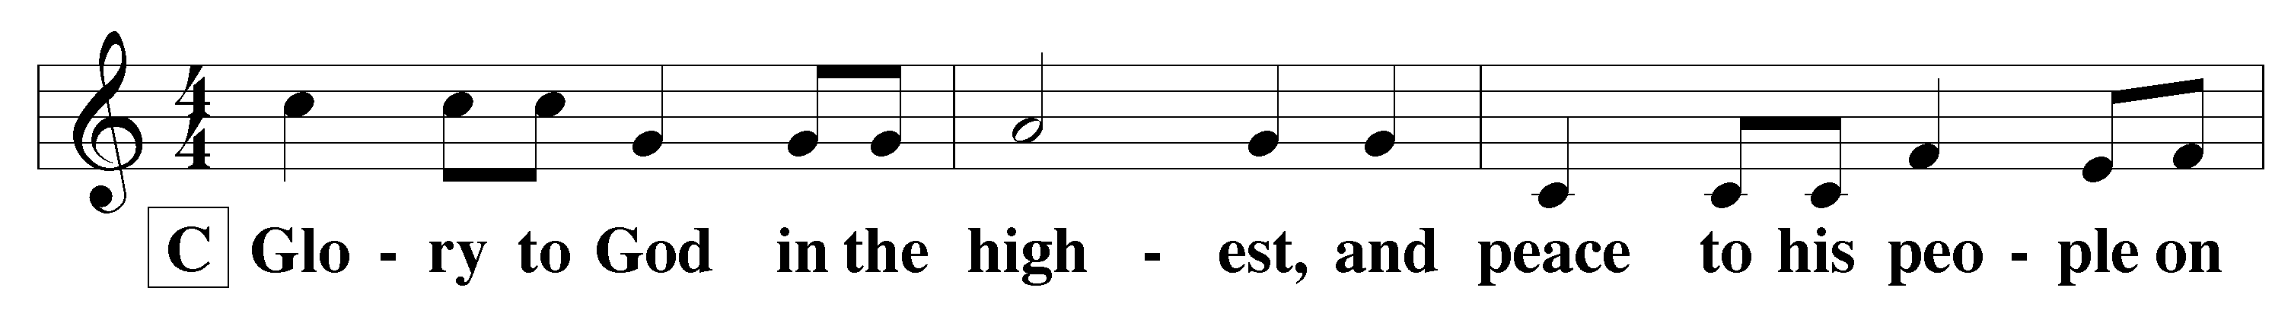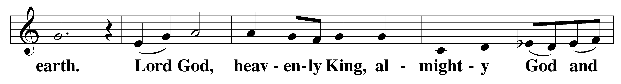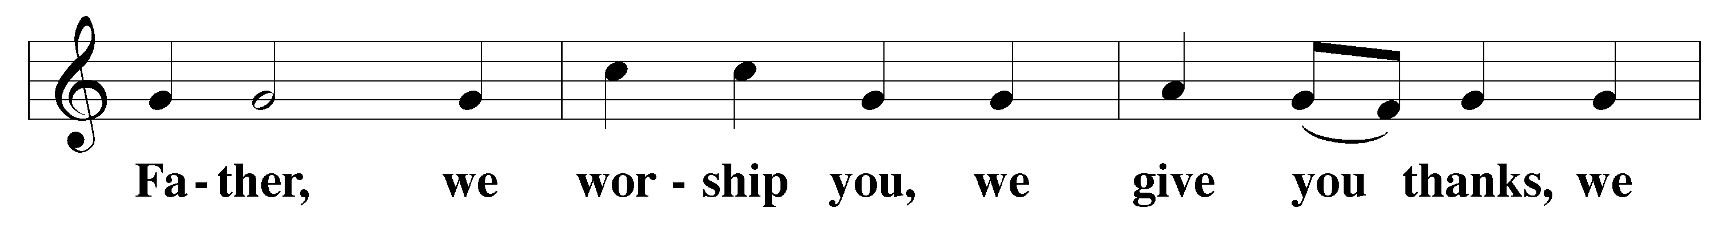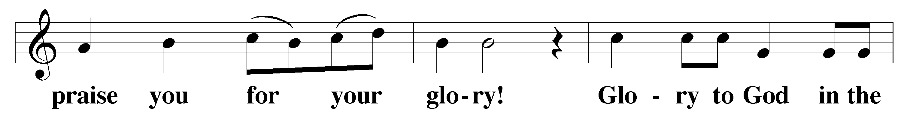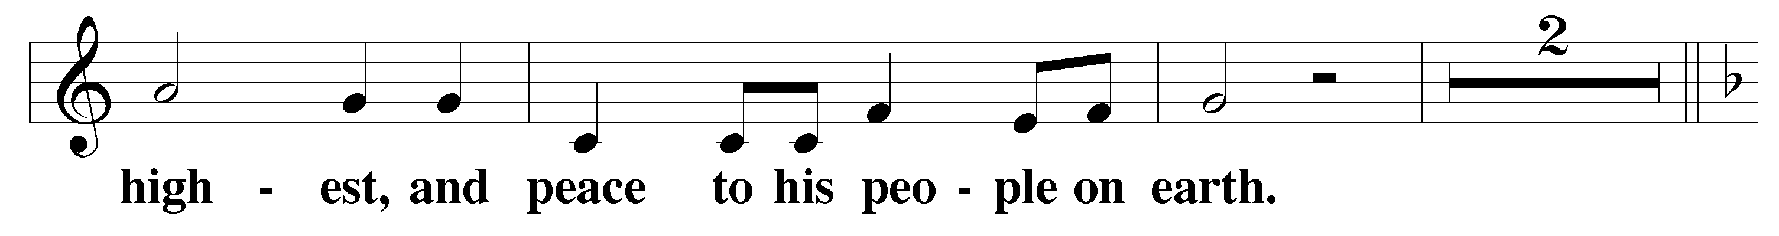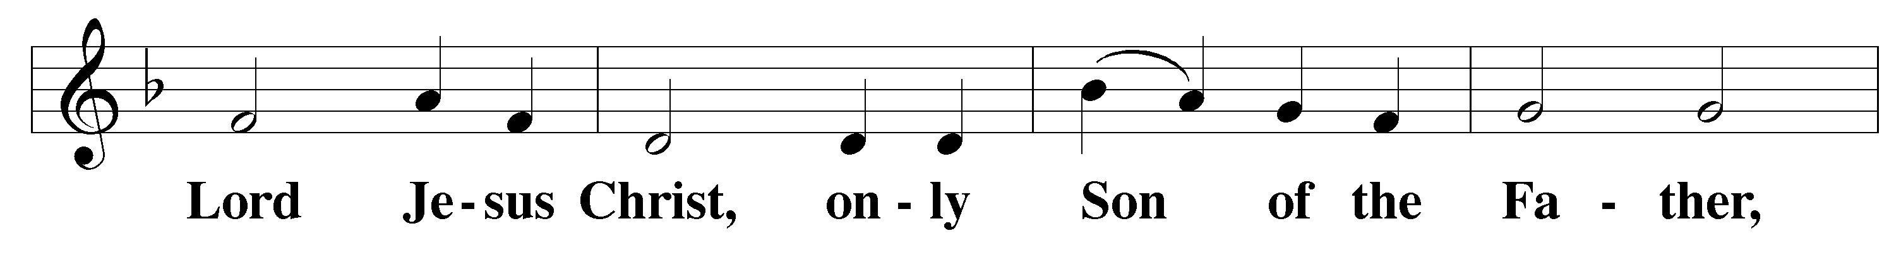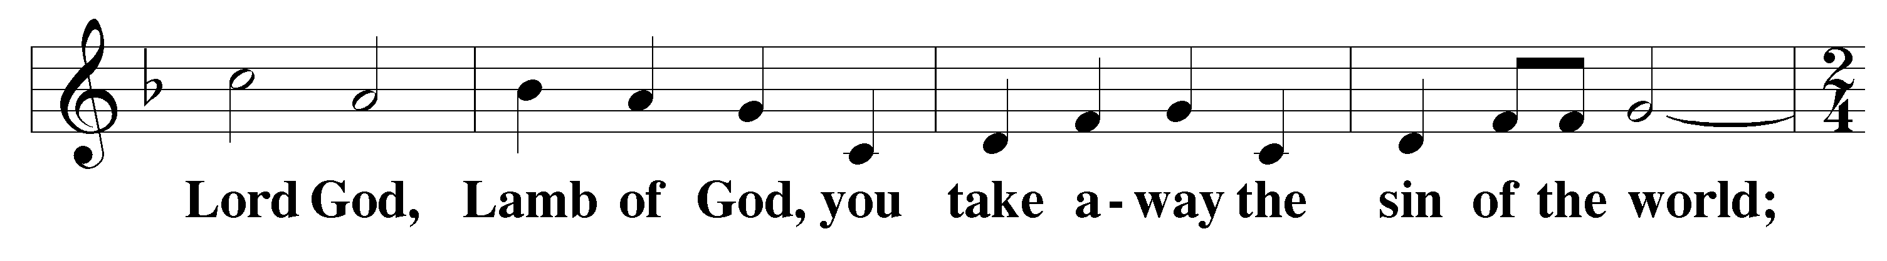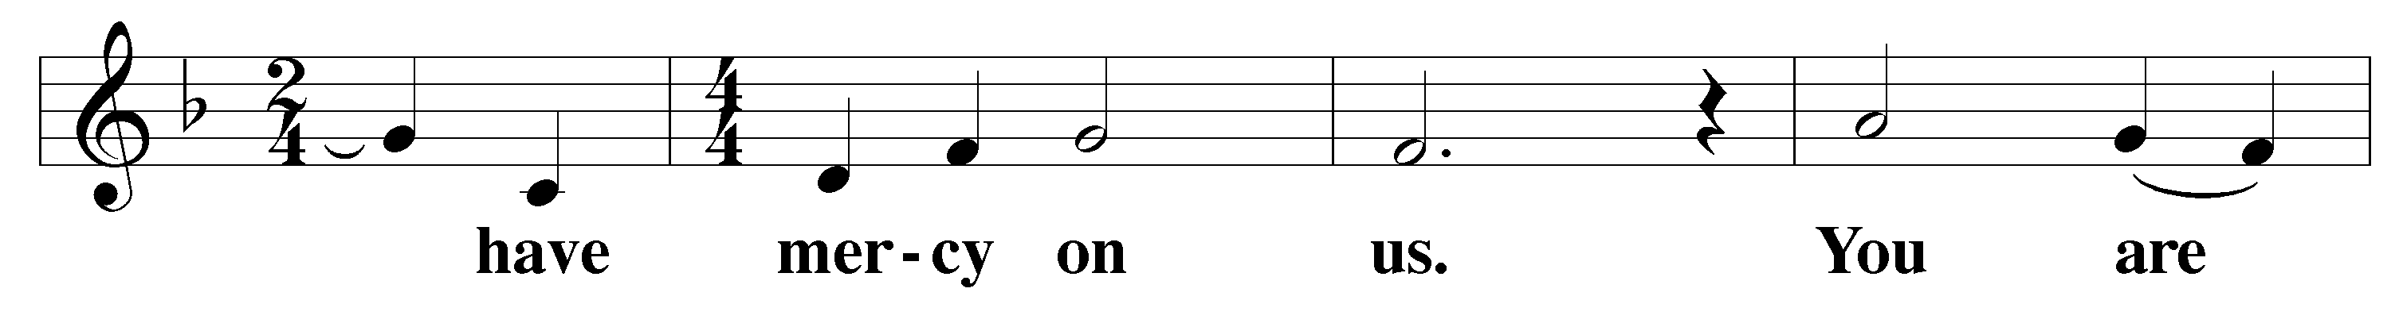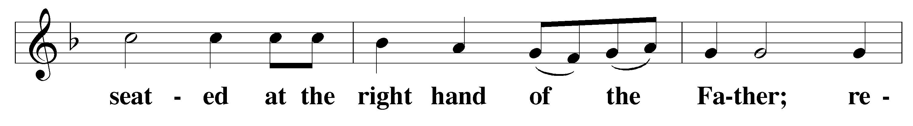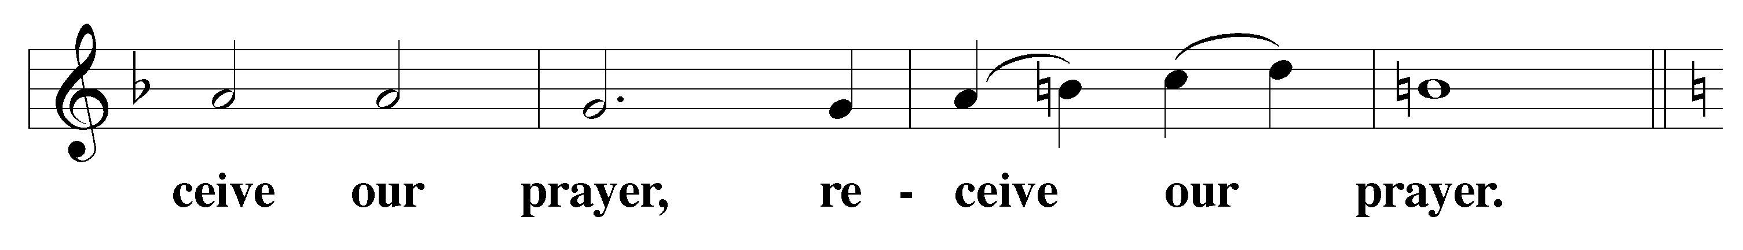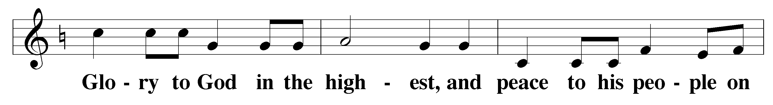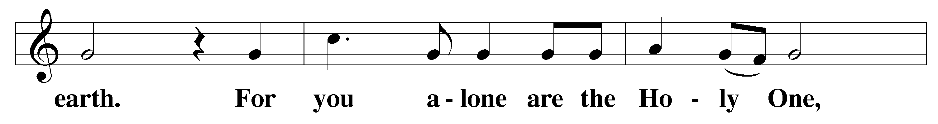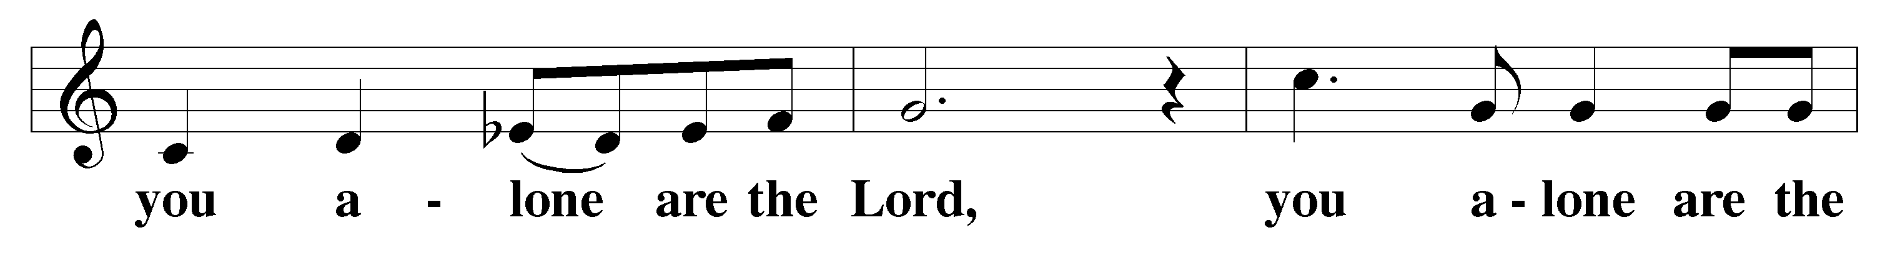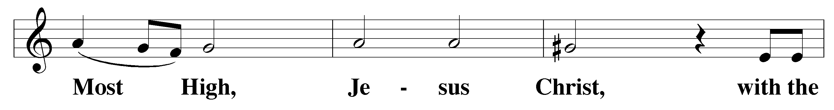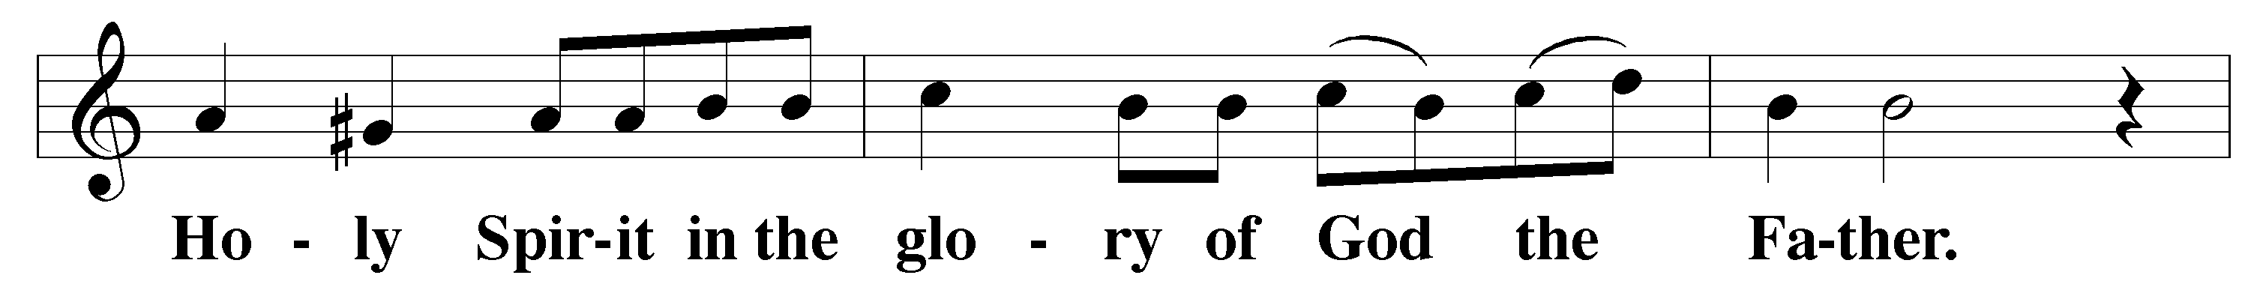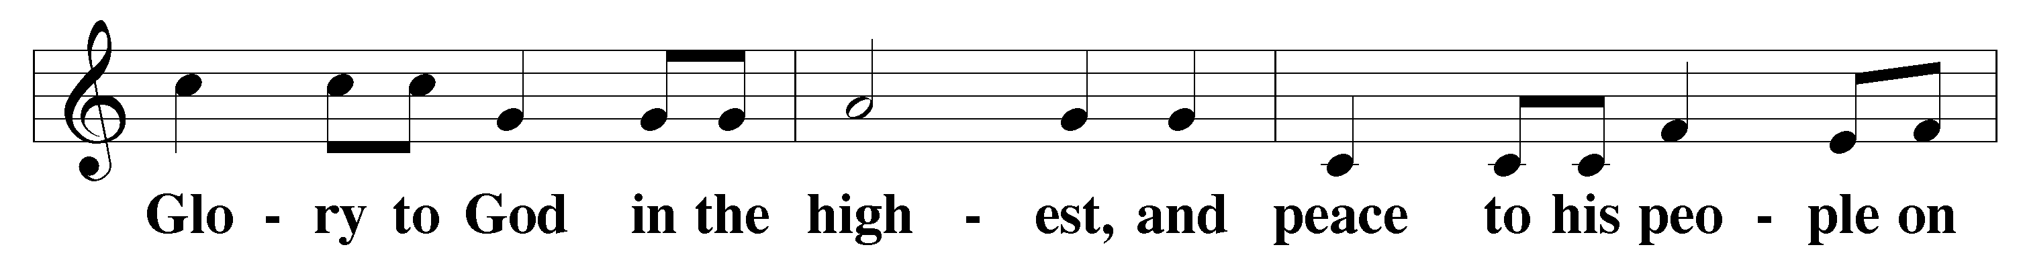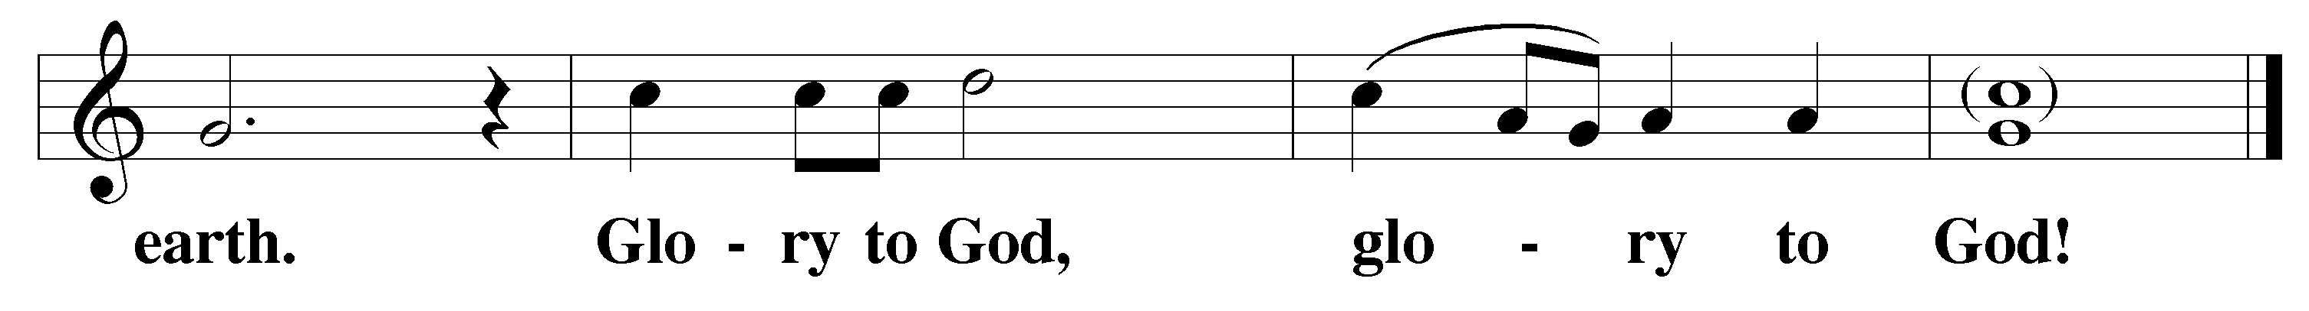

Prayer of the Day
The Lord be with you.
And also with you.
Let us pray.
Almighty God, look with favor on those whom you have called to minister to your people. Fill them with faithfulness to your doctrine and clothe them with holiness of life that they may joyfully serve to the glory of your name and for the benefit of your Church; through your Son, Jesus Christ our Lord, who lives and reigns with you and the Holy Spirit, one God, now and forever.
Amen.

First Lesson 1 Chronicles 28:8-10, 20
Our Strength Comes from the Lord

⁸ “So now I charge you in the sight of all Israel and of the assembly of the Lord, and in the hearing of our God: Be careful to follow all the commands of the Lord your God, that you may possess this good land and pass it on as an inheritance to your descendants forever.
⁹ “And you, my son Solomon, acknowledge the God of your father, and serve him with wholehearted devotion and with a willing mind, for the Lord searches every heart and understands every motive behind the thoughts. If you seek him, he will be found by you; but if you forsake him, he will reject you forever. ¹⁰ Consider now, for the Lord has chosen you to build a temple as a sanctuary. Be strong and do the work.” … ²⁰ David also said to Solomon his son, “Be strong and courageous, and do the work. Do not be afraid or discouraged, for the Lord God, my God, is with you. He will not fail you or forsake you until all the work for the service of the temple of the Lord is finished.

This is the Word of the Lord.
Thanks be to God.

Psalm of the Day Psalm 46
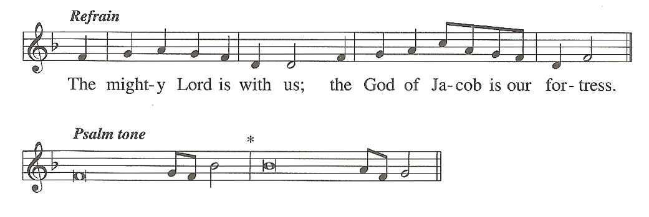
God is our re^fuge and strength,*
an ever-present help in ^trouble.
Therefore we will not fear, though the ^earth give way*
and the mountains fall into the heart ^of the sea,
though its waters ^roar and foam*
and the mountains quake with their ^surging.
Refrain
There is a river whose streams make glad the cit^y of God,*
the holy place where the Most ^High dwells.

God is within her, she ^will not fall;*
God will help her at ^break of day.
“Be still, and know that ^I am God;*
I will be exalted among the nations, I will be exalted ^in the earth.”
Glory be to the Father and ^to the Son*
and to the Holy ^Spirit,
as it was in the be^ginning,*
is now, and will be forever. ^Amen.
Refrain

M: The Gospel according to Matthew, chapter twenty-eight.

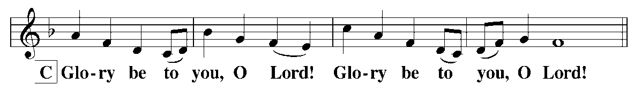

Gospel Matthew 28:16-20

The Great Commission
¹⁶ Then the eleven disciples went to Galilee, to the mountain where Jesus had told them to go. ¹⁷ When they saw him, they worshiped him; but some doubted. ¹⁸ Then Jesus came to them and said, “All authority in heaven and on earth has been given to me. ¹⁹ Therefore go and make disciples of all nations, baptizing them in the name of the Father and of the Son and of the Holy Spirit, ²⁰ and teaching them to obey everything I have commanded you. And surely I am with you always, to the very end of the age.”
M: This is the Gospel of the Lord.
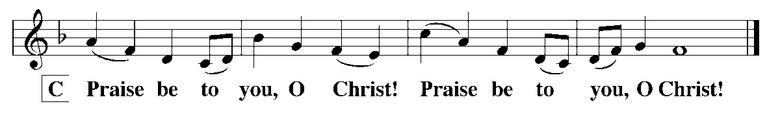

Hymn of the Day Christ Be My Leader - 367

Sermon John 10 Selected Verses

Confession of Faith The Apostles’ Creed
I believe in God, the Father almighty,
maker of heaven and earth.

I believe in Jesus Christ, His only Son, our Lord,
who was conceived by the Holy Spirit,
born of the virgin Mary,
suffered under Pontius Pilate,
was crucified, died, and was buried.
He descended into hell.
The third day He rose again from the dead,
He ascended into heaven
and is seated at the right hand of God the Father almighty.
From there He will come to judge the living and the dead.

I believe in the Holy Spirit,
the holy Christian Church,
the communion of saints,
the forgiveness of sins,
the resurrection of the body,
and the life everlasting. Amen.

Offering

Installation
Hymn Lord Jesus, You Have Come

Lord Jesus, you have come O blessed ministry
A teacher sent from heaven Of reconciliation,
And by both word and deed That shows the way to God
God’s truth to us have given. And brings to us salvation!
You wisely have ordained Lord, by your gospel pure,
The holy ministry You bless and keep your fold;
That we, your flock, may know You call, enlighten, keep;
The truth that sets us free. You comfort and uphold.

Rite of Installation

The pastor-elect presents himself before the altar, and the installing minister says:
Our Lord and Savior Jesus Christ said to his Church, “All authority in heaven and on earth has been given to me. Therefore go and make disciples of all nations, baptizing them in the name of the Father and of the Son and of the Holy Spirit, and teaching them to obey everything I have commanded you. And surely I am with you always, to the very end of the age.” When he had ascended higher than all the heavens, in order to fill the whole universe, he gave some to be apostles, some to be prophets, some to be evangelists, and some to be pastors and teachers, to prepare God’s people for works of service, so that the body of Christ might be built up.
Matthew 28:18-20, Ephesians 4:10-11

The installing minister addresses the pastor-elect:
Dear brother:
After careful instruction and examination in Christian doctrine, you have been presented to the church as one who is able to teach others. This congregation has called you to serve them in the office of the holy ministry. It is fitting, therefore, that you should hear again what God in his Word impresses on his pastors concerning the solemn responsibilities of their sacred office:

“Here is a trustworthy saying: If anyone sets his heart on being an overseer, he desires a noble task.
Now the overseer must be above reproach, the husband of but one wife, temperate, self-controlled, respectable, hospitable, able to teach, not given to drunkenness, not violent but gentle, not quarrelsome, not a lover of money. He must manage his own family well and see that his children obey him with proper respect. He must not be a recent convert, or he may become conceited and fall under the same judgment as the devil. He must also have a good reputation with outsiders, so that he will not fall into disgrace and into the devil’s trap.”
1 Timothy 3:1-7
“Preach the Word; be prepared in season and out of season; correct, rebuke and encourage — with
great patience and careful instruction. … Keep your head in all situations, endure hardship, do the work of an evangelist, discharge all the duties of your ministry.”
2 Timothy 4:2,5
“Set an example for the believers in speech, in life, in love, in faith and in purity. Until I come, devote
yourself to the public reading of Scripture, to preaching, and to teaching. Do not neglect your gift, which was given you through a prophetic message when the body of elders laid their hands on you. Be diligent in these matters; give yourself wholly to them, so that everyone may see your progress. Watch your life and your doctrine closely. Persevere in them, because if you do, you will save both yourself and your hearers.”
1 Timothy 4:12-16
As a minister of the gospel, you are Christ’s ambassador, commissioned by him to preach the Word and administer the sacraments. Our ascended Lord has given you as a gift to his body, the Church, and he has appointed you to love and serve it. You are called to offer prayers and intercessions for his people; to feed, to instruct, to watch over, and to guide the sheep and the lambs of God’s flock, remembering that Christ has bought each of them with his own blood. You are also called to protect the flock from savage wolves who, as the Scriptures say, will try to scatter it. Since no one is competent in himself for such a ministry, you will gladly seek the strength which Christ alone can provide by devoting yourself to meditation and study of the Scriptures. Only by being nourished in the truths of the faith will you be able to carry out the duties of this office and set an example in godliness and Christian living.

In keeping with the word and will of the Lord, you are about to be installed as pastor of Christ Evangelical Lutheran Church. I now ask you in the presence of God and this congregation:

Are you fully determined to carry out this work as pastor according to the grace which God will give?
Pastor-elect I am.

Do you believe that the canonical books of the Old and New Testament are the inspired Word of God and the only infallible rule of faith and practice?
Pastor-elect I do.

Do you accept the three Ecumenical Creeds — the Apostles’, the Nicene, and the Athanasian — as faithful testimonies to the truth of the Holy Scriptures, and do you reject all the errors which they condemn?
Pastor-elect I do.

Do you believe that the Unaltered Augsburg Confession is a true exposition of the Word of God and a correct presentation of the doctrine of the Evangelical Lutheran Church; and that the Apology of the Augsburg Confession, the Small and Large Catechisms of Martin Luther, the Smalcald Articles, and the Formula of Concord, as contained in the Book of Concord, are also in agreement with this one scriptural faith?
Pastor-elect I do.

Do you solemnly promise that all your teaching and your administration of the Sacraments will conform to the Holy Scriptures and the Lutheran Confessions?
Pastor-elect I do.

Will you give faithful witness to Christ in the world that God’s love may be known in all that you do and say?
Pastor-elect I will, and I ask God to help me.

Almighty God, who has given you the will to do these things, graciously give you the strength and compassion to perform them.

The installing minister addresses the congregation:
Brothers and sisters in Christ:
You have heard the solemn promise given by the one you have called to be your pastor. I urge and command you, therefore, to receive him as your pastor, and always to keep in mind what the Word of God expects of you as members of his flock:

Listen eagerly to the preaching of the Word, receiving it not as the word of men, but as it actually is, the Word of God.

Take to heart his scriptural words of warning and encouragement, humbly accepting the word planted in you.

Work together with him for our Lord’s kingdom so that by your works of service the body of Christ might be built up.

Help him by your word and example in teaching the young, remembering how the Scriptures urge you to bring up your children in the training and instruction of the Lord.

Honor and love him, as the Apostle Paul says, “Respect those who work hard among you, who are over you in the Lord and who admonish you. Hold them in the highest regard in love because of their work.”
Pray for him continually, that his ministry among you may be greatly blessed and that, with all his responsibilities, he may continue to have a cheerful spirit.

Provide also for his physical needs, for the Lord says, “The worker deserves his wages;” and the Apostle Paul says, “Anyone who receives instruction in the Word must share all good things with his instructor.”
Finally, remember what the Scriptures say, “Obey your leaders and submit to their authority. They keep watch over you as men who must give account. Obey them so that their work will be a joy, not a burden, for that would be of no advantage to you.”

The members of Christ Lutheran Church stand.
I now ask you, in the presence of God:
Are you willing to receive your pastor as a minister of God? Will you show him the love, honor and obedience in the Lord which you owe to a shepherd and overseer placed over you by the Lord Jesus Christ, the Chief Shepherd and Overseer of souls? If so, answer:
Yes, and we ask God to help us.
Yes, and we ask God to help us.

The almighty and merciful God strengthen and assist you always.
The members of the congregation are seated.

The pastor-elect kneels, and the installing minister, laying his right hand on his head, says:
Tim Leistekow, I install you as pastor of Christ Lutheran Church in the name of the Father and of the Son and of the Holy Spirit.

May the Lord pour out on you his Holy Spirit for the work committed to you that you may faithfully proclaim the gospel in Word and Sacraments.

The ministers participating in the rite of installation shall, in turn, lay their right hands on the head of the newly installed pastor and speak an appropriate Bible passage and words of encouragement.

Prayer
Let us pray.
O Lord God, heavenly Father, you are the one who sends out pastors to serve your Holy Church; yet they will be unable to do this unless you give them power from on high. Fill your servant with your Holy Spirit. Lead and guide him with your strong right hand that he may faithfully carry out the ministry entrusted to him, and so bring glory to your name and blessings to your people; through your Son, Jesus Christ, our Lord.
Amen.

Lord’s Prayer
Our Father, who art in heaven, hallowed be thy name, thy kingdom come, thy will be done on earth as it is in heaven. Give us this day our daily bread; and forgive us our trespasses, as we forgive those who trespass against us; and lead us not into temptation but deliver us from evil. For thine is the kingdom and the power and the glory forever and ever. Amen.

Blessing
Go then, take up the work to which you have been called. The Lord bless you and make you a blessing to many, that you may bear fruit and that your fruit may remain to eternal life. Amen.

Hymn Lord Jesus, You Have Come
The servants you have called Bring those into your fold
And to your Church are giving Who still to you are strangers;
Preserve in doctrine pure Guard those who are within
And holiness of living. Against offense and dangers.
Your Spirit fill their hearts Press onward with your Word
And charge their words with pow’r; Till pastor and his fold
What they should boldly speak, Through faith in you, O Christ,
Oh, give them in that hour! Your glory shall behold.

Prayer and Blessing by the Newly-Installed Pastor
The Lord bless you and keep you.
The Lord make his face shine on you and be gracious to you.
The Lord look on you with favor and give you peace.
Amen.

Recessional Hymn We Bid You Welcome in the Name - 547

Announcements

Service Participants

Presiding Minister Pastor Christopher Hoppe
Pastor, St John Lutheran Church
Vacaville, CA

Preacher Pastor Philip Janisch
Pastor, Peace Lutheran Church
Vancouver, WA

Installing Minister Pastor Jon Buchholtz
Emmanuel Lutheran Church, Tempe, AZ
President, AZ-CA District

Pianist Rosemarie Boushek

Pastor Tim Leistekow
The Leistekow family extend their thanks to the members of Christ Lutheran for their generosity and hospitality as they make the transition to California. Pastor Leistekow is looking forward to serving the saints at Christ Lutheran.

Everyone is invited to a reception for Pastor Tim and Calista
in the Fellowship Hall immediately following the installation service.

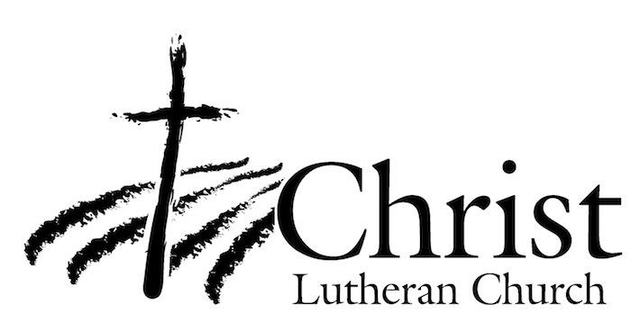
13009 N. Elderberry Ct.
Lodi, CA 95242
www.christlodi.org
209-368-6250
WELCOME TO CHRIST EV. LUTHERAN CHURCH!
We preach a message of forgiveness, hope and peace
through the death and resurrection of Jesus Christ.
Families and individuals of all ages will find opportunities
both to grow and to serve.
Our mission statement:
Look what Christ is doing!
He binds us together in fellowship
He gathers us in for worship
He builds us up for service
He sends us out with the gospel

“Now you are the body of Christ,
and each one of you is a part of it.”
(1 Corinthians 12:27)

